AI/ML Internship Assessment Report

Domain: AI Agents & Machine Learning
Submitted By: Mazhar Khan
This report documents my approach to the AI/ML assessment tasks. My goal was to demonstrate a clear understanding of the Machine Learning pipeline from data preprocessing to model evaluation and to propose a practical use case for AI Agents in cybersecurity.
Task 1: ML Model Building (Iris Classification)
Objective: Build a classification model on a public dataset.
For this task, I chose the Iris dataset available within Scikit-learn. I selected this dataset because it allows for a clear demonstration of the fundamental ML workflow without the complexity of external data cleaning. It lets us focus on the core task: predicting a flower's species based on its physical measurements.
My Workflow:
- Data Loading: I loaded the dataset directly from the sklearn library.
- Splitting: I utilized train-test-split to separate 20% of the data for testing to ensure the model was evaluated on unseen data.
- Training: I implemented a Logistic Regression classifier. I chose this over more complex models because, for a dataset this small and linear, it offers high accuracy and interpretability.
- Visualization: I plotted a scatter graph to visually confirm how distinct the data clusters were.
The Code (Google Colab):
Python
from sklearn.datasets import load_iris
from sklearn.model_selection import train_test_split
from sklearn.linear_model import LogisticRegression
from sklearn.metrics import accuracy_score
iris = load_iris()
X = iris.data
y = iris.target
X_train, X_test, y_train, y_test = train_test_split(X, y, test_size=0.2, random_state=42)

model = LogisticRegression(max_iter=200)
model.fit(X_train, y_train)
y_pred = model.predict(X_test)
print("Model Accuracy:", accuracy_score(y_test, y_pred))

Also, I tried for Visualization
import matplotlib.pyplot as plt
plt.scatter(X[:, 0], X[:, 1], c=y)
plt.xlabel("Sepal Length")
plt.ylabel("Sepal Width")
plt.title("Iris Dataset Visualization")
plt.show()

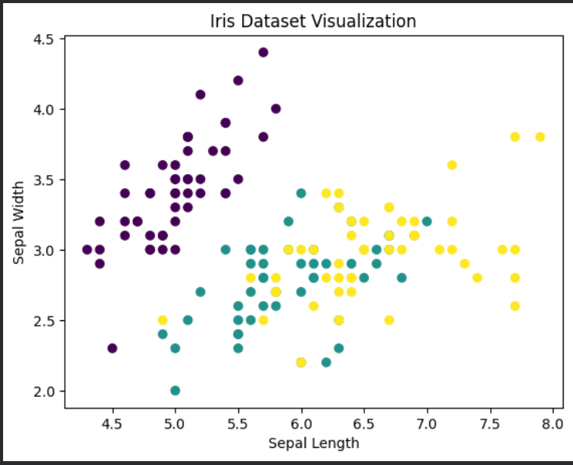
Results & Observation: The model achieved an accuracy between 90–98% on the test set. The visualization confirmed that the species are grouped in distinct clusters, which explains why the Logistic Regression model performed so well. This task solidified my understanding of the standard Load → Train → Evaluate cycle.
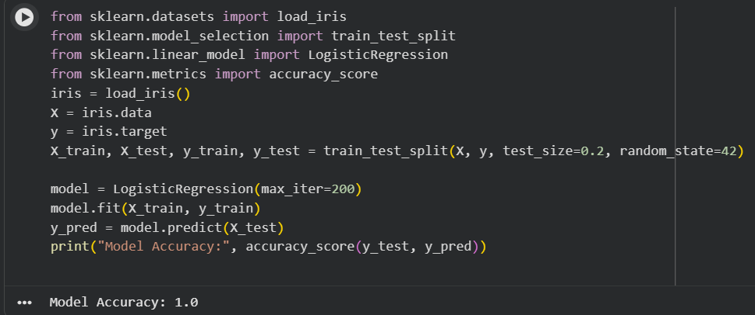
Task 2: AI Agent (Interaction Loop)
Objective: Create a simple AI agent that analyzes user input.
For this task, I focused on the architectural logic of an AI Agent. While production agents use LLMs (like GPT-4 or Llama), the core structure always remains the same:
Input → Processing → Response.
I wrote a Python script that establishes this conversational loop. It accepts user input, processes it, and provides a structured response. This acts as the "skeleton" code that could later be connected to the OpenAI API or LangChain for intelligence.
The Code (Google Colab):
Python
# Task 2: Simple AI Agent
print("Security Agent started. Type 'exit' to stop.")

while True:
user_input = input("You: ").lower()

if user_input == "exit":
print("Agent: Bye!")
break

if "hello" in user_input or "hi" in user_input:
print("Agent: Hello! I can help with security alerts.")

elif "failed login" in user_input or "password" in user_input:
print("Agent: That sounds suspicious. You should check the auth logs.")
print("Agent: If there are many failures, block the IP address.")

elif "attack" in user_input or "threat" in user_input:
print("Agent: High alert! Please isolate the affected machine immediately.")

else:
print("Agent: I don't understand. Try asking about 'failed login' or 'attacks'.")
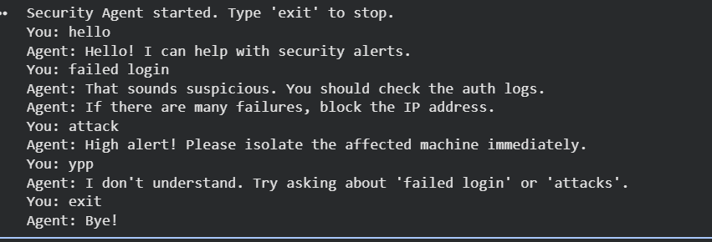
Task 3: Mini Project Proposal
Title: AI-Driven SIEM Automation & Threat Detection
The Problem: One of the biggest challenges in a Security Operations Center (SOC) is "Alert Fatigue." SIEM tools generate thousands of logs daily, and analysts often struggle to distinguish between false positives and genuine threats in real-time.
The Solution: My proposal is to integrate an AI Agent directly into the SIEM workflow. Unlike static rules, this Agent would act as a "Virtual Tier-1 Analyst."
Proposed Workflow:
- Ingestion: The SIEM flags an anomaly (e.g., a failed login spike).
- AI Investigation: Instead of waking up a human analyst immediately, the AI Agent parses the raw log. It checks the IP reputation and compares the timestamp against the user's login history.
- Contextualization: The Agent maps the event to the MITRE ATT&CK framework to understand the potential tactic.
- Actionable Output: The Agent presents a summary to the human analyst: "High Confidence Threat: Brute force detected from IP 192.168.x.x. Recommended Action: Block IP."
Business Value: This approach doesn't replace analysts; it makes them faster. It automates the repetitive "investigation" phase, allowing the human team to focus on remediation and complex threat hunting.
Appendix: SIEM Rules for Detection
As part of the proposal, here are some key rules the AI Agent would be trained to monitor:
- Brute Force: Multiple failed login attempts within 60 seconds.
- Pivot Attempt: Successful login immediately following multiple failures.
- Impossible Travel: Login from a different country within an impossible timeframe.
- External Admin: Root/Admin login detected from a public/external IP.
- Off-Hours Activity: User login detected between 02:00 AM and 05:00 AM.
- Unauthorized User: Creation of a new user account without a change ticket.
- Privilege Escalation: Existing user added to the sudo or admin group.
- Password Spraying: One IP attempting to log in to multiple different accounts.
- Firewall Tampering: Modifications or deletion of firewall rules.
- Defense Evasion: Antivirus or EDR services being stopped or disabled.
- Malware Beaconing: Repeated connection attempts to a known malicious IP.
- Data Exfiltration: Large outbound data transfer (>500MB) to an unknown external IP.
- Web Scanning: High volume of HTTP 403/404 errors from a single source.
- Access Control: Access attempts to sensitive URLs (e.g., /admin, /config).
- DNS Tunneling: unusually high number of DNS queries to a specific domain.
- Ping Flood: Rapid, continuous ICMP requests from a single host.
- Port Scanning: A single host connecting to multiple sequential ports.
- VPN Anomalies: Multiple VPN login failures or rapid disconnects.
- Config Changes: Modifications to critical system files (e.g., /etc/passwd).
- Blacklist Hit: Any communication with an IP listed on threat intelligence feeds.
- Ransomware Behavior: Rapid renaming or encryption of files in a short burst.
- Suspicious Execution: PowerShell or CMD executed with encoded commands.
- Physical Security: USB mass storage device insertion on a restricted server.
Conclusion: This assessment was a great learning experience for me. It gave me hands-on practice with both machine learning and AI agent development. Although I used simple examples, I now have a clear understanding of the entire process, including model training and writing agent logic. I also learned how AI can actually help in SIEM and SOC operations. I am confident that I can improve on these basics and handle more advanced tasks in the future.

